Infix Expression: **A+ (B*C-(D/E^F)*G)*H**, where **^** is an exponential operator.

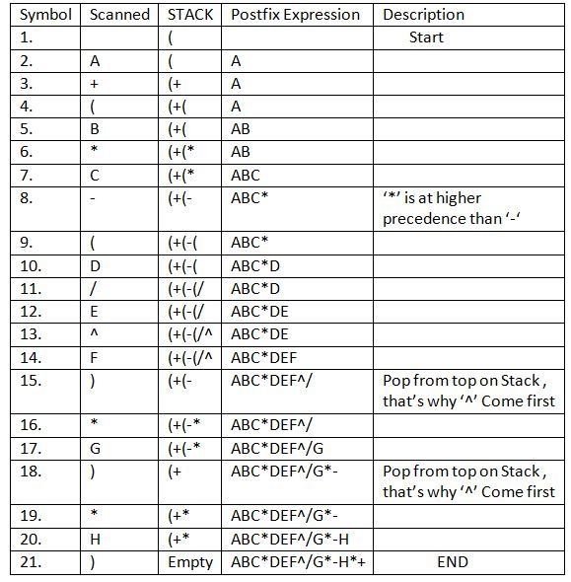

Convert the following infix expression A + B * C – D / E * H into its equivalent postfix expression.

|  |  |  |  |
| --- | --- | --- | --- |
| Symbol | Postfix string | Stack | Remarks |
| A | A |  |  |
| + | A | + |  |
| B | A B | + |  |
| * | A B | + * |  |
| C | A B C | - |  |
| - | A B C * + | - |  |
| D | A B C * + D | - |  |
| / | A B C * + D | - / |  |
| E | A B C * + D E | - / |  |
| * | A B C * + D E / | - * |  |

**Procedure for converting infix- Prefix**

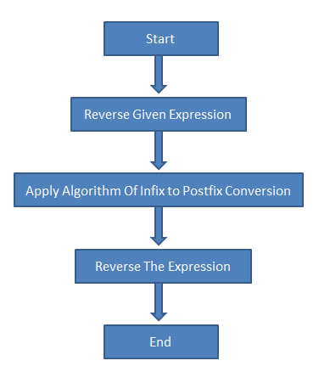

|  |  |  |  |
| --- | --- | --- | --- |
| H | A B C * + D E / H | - * |  |
| End of string | A B C * + D E / H * - | The input is now empty. Pop the output symbols from the stack until it is empty. | |